MongoDB Lab – Day 6 (Advanced Queries)
Schema
{ emp_id, name, department, designation, city, salary, experience }
Initial Data
Same 10 employee documents as Lab 5.
Emp ID | Name | Department | Designation | City | Salary | Experience
101 | Amit | IT | Developer | Kolkata | 60000 | 3
102 | Neha | HR | HR Executive | Delhi | 45000 | 2
103 | Ravi | IT | Tester | Mumbai | 50000 | 4
104 | Pooja | Finance | Accountant | Chennai | 55000 | 5
105 | Karan | IT | Developer | Kolkata | 65000 | 6
106 | Sneha | HR | Manager | Delhi | 70000 | 7
107 | Arjun | Finance | Analyst | Mumbai | 48000 | 2
108 | Meera | IT | Developer | Bangalore | 75000 | 8
109 | Rohit | IT | Team leader | Pune | 90000 | 10

Questions
Q1. Display employee name and salary only.
Query: db.employees_cse_204.find({}, { name: 1, salary: 1, _id: 0 })

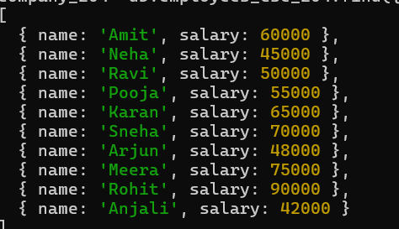
Q2. Find employees working in HR department.
Query: db.employees_cse_204.find({ department: "HR" })
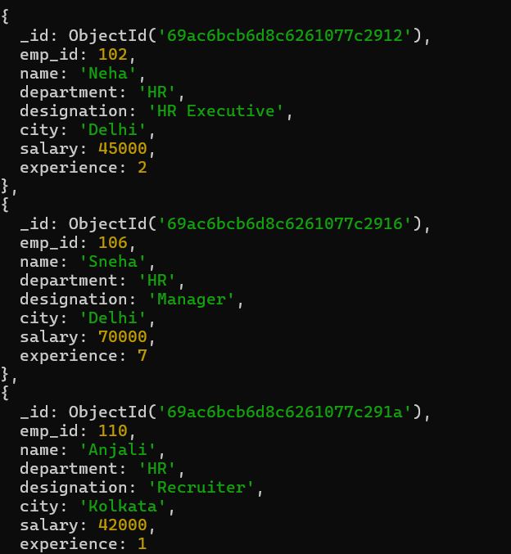
Q3. Find employees whose salary is between 50,000 and 80,000.
Query:db.employees_cse_204.find({ salary: { $gte: 50000, $lte: 80000 } })
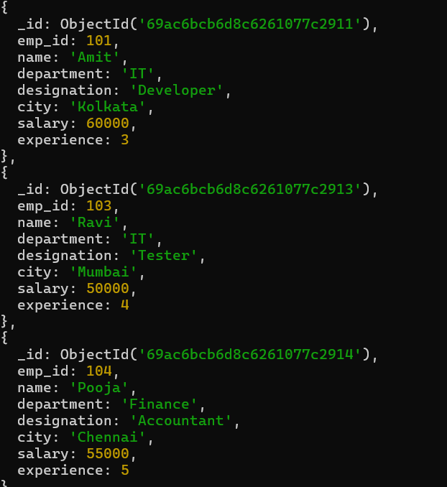

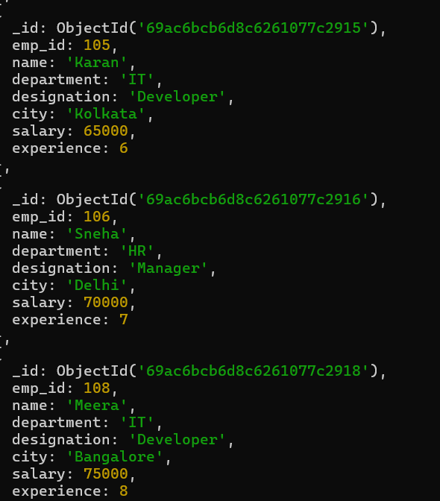
Q4. Display employees from Kolkata city.
Query:db.employees_cse_204.find({ city: "Kolkata" })
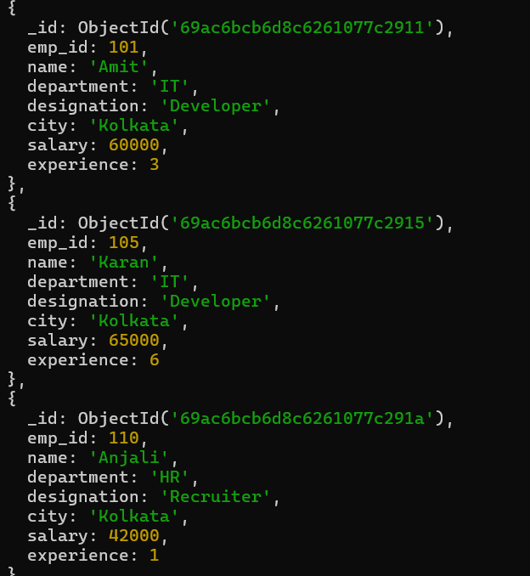

Q5. Sort employees by experience in ascending order.
Query: db.employees_cse_204.find().sort({ experience: 1 })
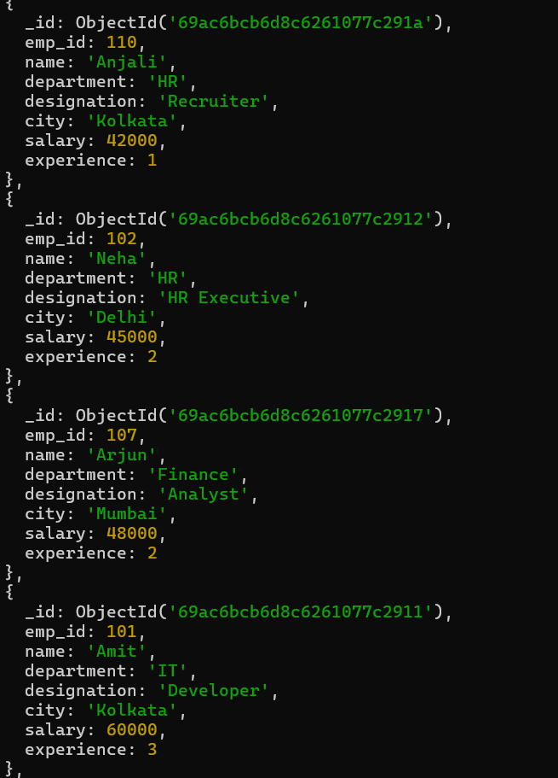
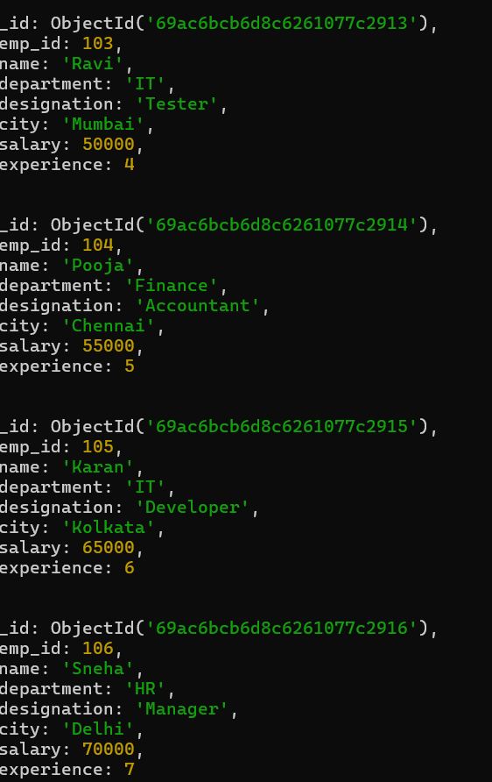
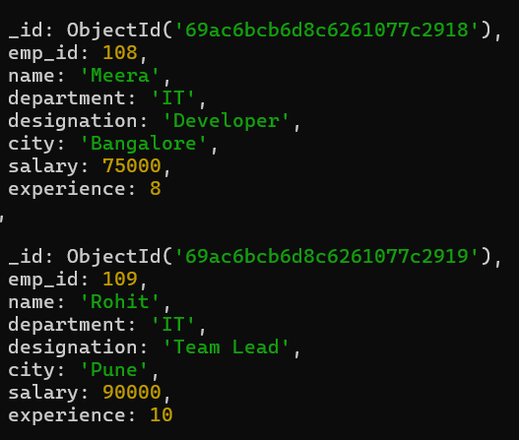
Q6. Display top 5 most experienced employees.
Query:db.employees_cse_204.find().sort({ experience: -1 }).limit(5)
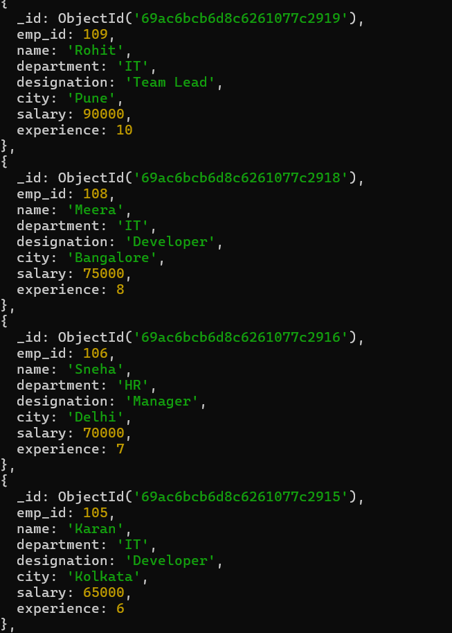

Q7. Update salary of employee with emp_id 102 to 48,000.
Query: db.employees_cse_204.updateOne({ emp_id: 102 }, { $set: { salary: 48000 } })
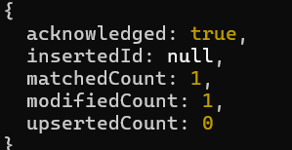
Q8. Increase salary of all IT employees by 10,000.
Query: db.employees_cse_204.updateMany({ department: "IT" }, { $inc: { salary: 10000 } })
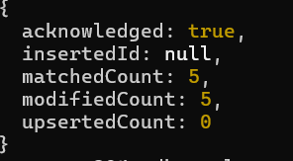
Q9. Update designation to “Senior Developer” for IT employees having experience more than 5 years.
Query: db.employees_cse_204.updateMany({ department: "IT", experience: { $gt: 5 } }, { $set: { designation: "Senior Developer" } })
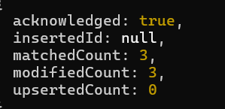
Q10. Delete employees whose experience is less than 2 years.
Query:db.employees_cse_204.deleteMany({ experience: { $lt: 2 } })
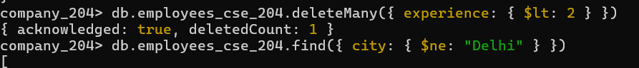
Q11. Display employees who are not from Delhi.
Query:db.employees_cse_204.find({ city: { $ne: "Delhi" } })
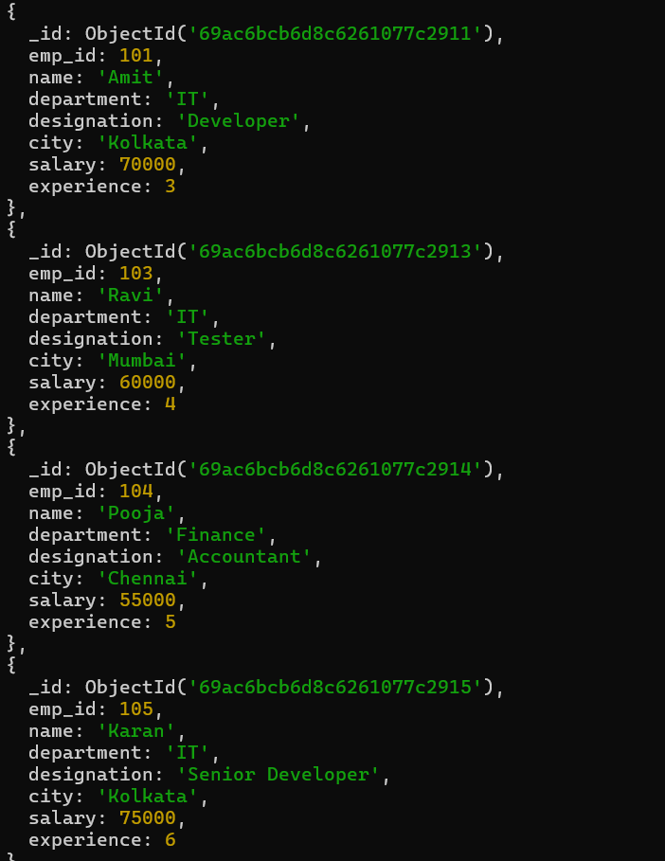
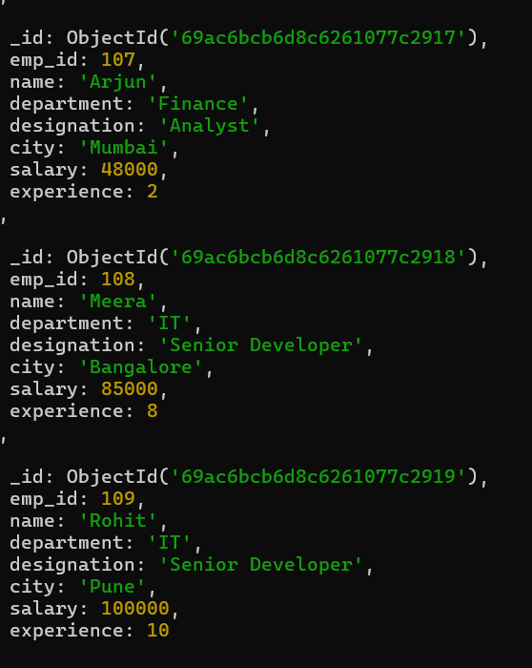

Q12. Find employees whose designation is Developer and salary greater than 60,000.
Query:db.employees_cse_204.find({ designation: "Developer", salary: { $gt: 60000 } })
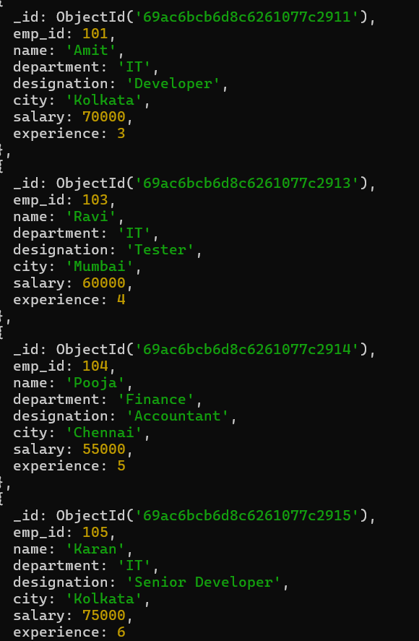
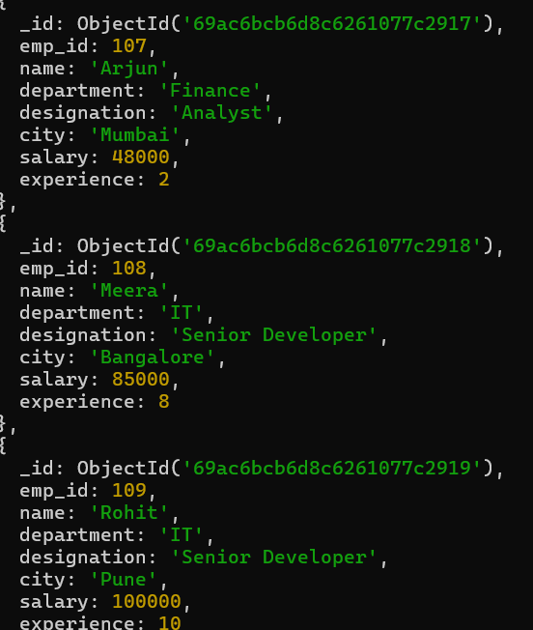

Q13. Display employees working in IT or Finance department.
Query:db.employees_cse_204.find({ department: { $in: ["IT", "Finance"] } })
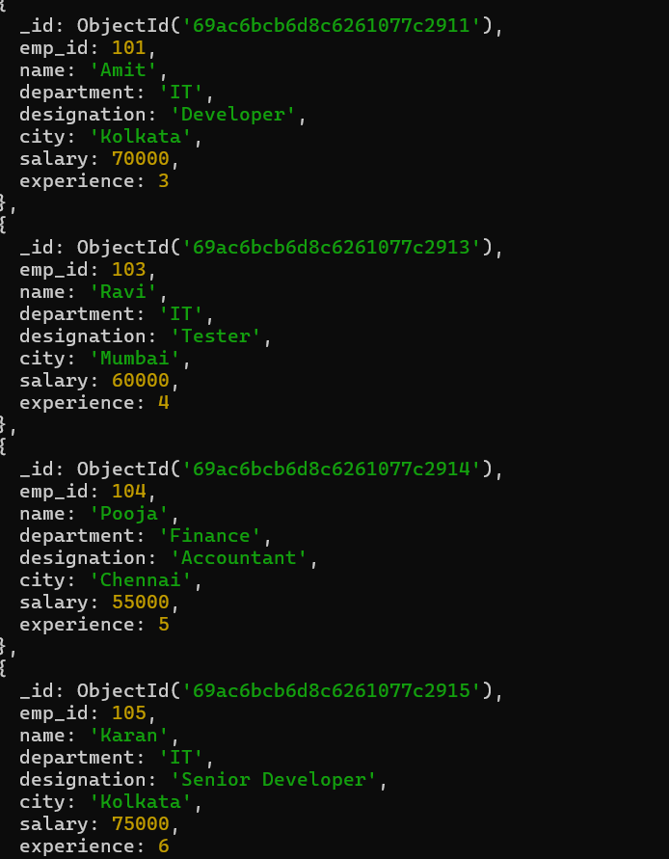
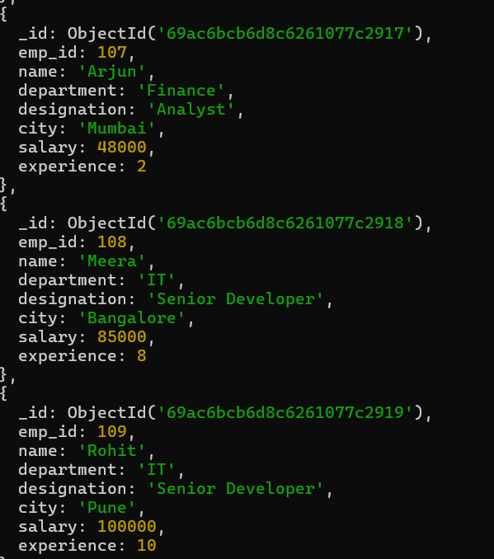

Q14. Display employees sorted by department and then by salary.
Query: db.employees_cse_204.find().sort({ department: 1, salary: 1 })
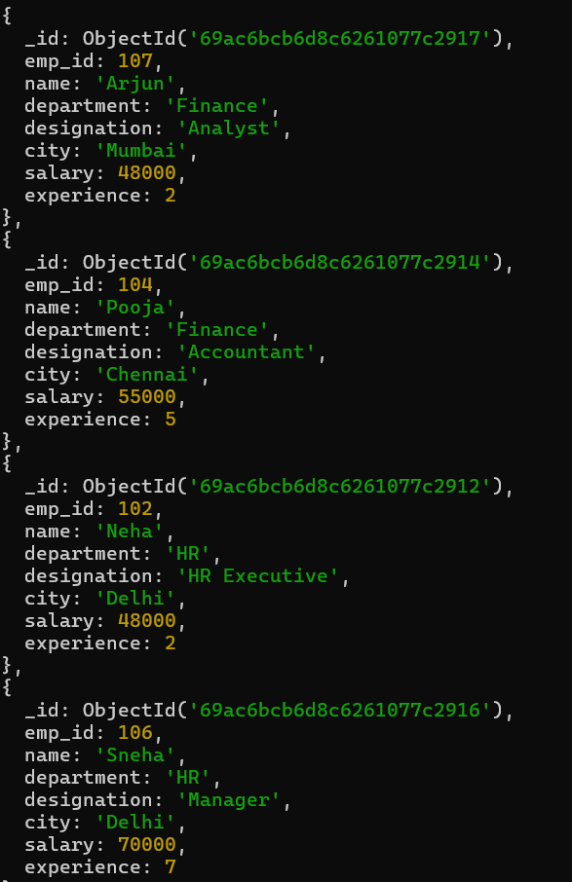
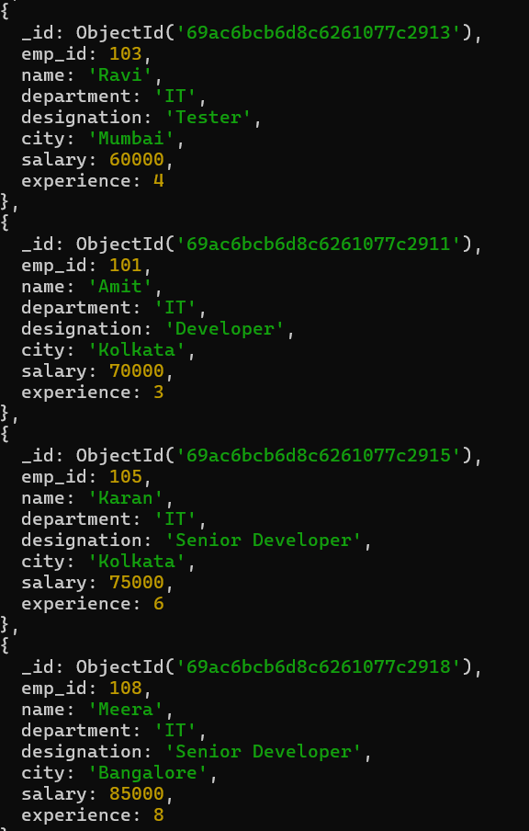

Q15. Count total number of employees in the company.
Query:db.employees_cse_204.countDocuments({})
Output:10
Q16. Display employees whose salary is not equal to 50,000.
Query: db.employees_cse_204.find({ salary: { $ne: 50000 } })
